Keystore Design SGL.GT0140.060

Security Classification: | Confidential
Document Reference: | SGL.GT0140.060
Status: | Draft
Version: | 1.0
Last Revised Date: | 18th September 2002
Team/Department : | Security
Author(s): | Jo Stichbury
Owner(s): | Leon Clarke

Approver(s): | Katie Sheehy | Distribution: | Security Team

Contents
1 Introduction 2
1.1 Purpose and Scope 2
2 The Filetokens Components 3
2.1 History of the file based certificate and key stores 3
2.1.1 The file based certificate store “filecertstore” becomes the filetokens client/server 3
2.1.2 The file based key store joins filetokens as a new tokentype 3
2.2 The components of filetokens 3
2.2.1 Overview 3
2.2.2 The filetokens client (fstokencli.dll) 4
2.2.3 The filetokens server (fstokenserver.exe) 4
2.3 Example command sequences for standard filetokens actions 6
2.3.1 Client-Server Startup, ListTokens and Open Token call on tokentype 7
2.3.2 Client side token interface acquisition and release of token interface, token and tokentype 8
2.3.3 Server side opening of a token not previously opened by that server session 9
2.3.4 Server side opening a token previously opened by that server session 10
2.3.5 Server side opening a token interface and returning a client lookup handle to that interface 10
2.3.6 Client side key creation 11
2.3.7 Server side key creation 12
3 Further Information 13
3.1 People 13
3.2 References 13
3.3 Open Issues 13
3.4 Glossary 13
3.5 Document History 13
3.6 Document Review Date 13
Appendix A - CTFramework 14
A.1 Use of CTFramework interfaces 14

Introduction

Purpose and Scope
This document describes the design of the file keystore in the jetstream security subsystem. The keystore is a component part of the filetokens client and server, the design of which is discussed with particular reference both to generic code and to specialisation for the keystore.
The document is designed to provide information additional to that available by inspection of the filetokens source code (Perforce mainline //EPOC/main/generic/security/filetokens/…). It is targetted at software engineers maintaining the filetokens code base, and those wishing to know more about the internal design of the filetokens client and server.
Those wishing to use the interfaces available to access and use the Jetstream security keystore should instead read the in-source documentation generated for those interfaces (which can be found on the intranet at http://securitysilo.dyndns.org/doxygen/).

The Filetokens Components

History of the file based certificate and key stores

The file based certificate store “filecertstore” becomes the filetokens client/server
The pre-Jetstream implementation of the file based certificate store was a single plugin dll, loaded by ECOM for each “client” requiring access to the filecertstore. The introduction of Platform Security in Jetstream places a requirement that the file store be subject to “data caging” and also deems as unsound the dynamic loading of dlls into a trusted computing base (TCB). These requirements suggest that the filecertstore should be implemented by an EPOC server with its own private data area, accessed by client sessions. The client should be accessible directly by those components which form part of the TCB, such as software install, which cannot use ECOM. Rather than remove ECOM dependence totally, an additional mechanism has been provided as an alternative means to access the filecertstore.
The suggested client/server design was intentionally made as generic as possible to provide a base client/server framework for future implementations of ctframework tokentypes such as the filebased keystore this document describes.

The file based key store joins filetokens as a new tokentype
The pre-Jetstream implementation of the file based keystore was a minor component used to implement basic key lookup functionality which was accessed by the certificate store for user certificate checking and filtering. Jetstream introduces more useful key manipulation through two new ctframework token interfaces for key usage and key management. The filebased keystore is implemented as a separate tokentype within the filetokens server, sitting alongside the filecertstore.
Access to the filekeystore will normally be made through the unified keystore (certstore.dll). The unified keystore previously reflected the limited operations available on the keystore and has now been extended to allow access to the additional key operations provided by the filetokens keystore. The unified keystore supports most of the operations supplied by the token interfaces for keystore use and management by providing an API reflecting those interfaces exactly. The exceptions to this are for adding and importing keys to the unified keystore because it becomes necessary to stipulate exactly which keystore is to have the key added to it. The addition operations are thus supported by the unified keystore but not parameterised as for the token interfaces because of the need to identify to the unfied keystore which keystore to make the addition/import upon.

The components of filetokens

Overview
Client side, separate ECOM plugin dlls are provided for each tokentype, filekeystore or filecertstore. These are nothing more than the implementation of a single entry point, ImplementationGroupProxy, to allow it to be loaded dynamically by ECOM as previously. Each is statically linked to the filetokens client dll (fstokencli.dll).
The filetokens client dll contains generic code which makes it reusable for each tokentype, and specialised code to implement each of the ctframework interfaces supported by the tokentypes. The only function exported by the client is a NewL() function which is parameterised by the UID of the required tokentype (see Appendix A for details). This may thus be accessed by ECOM or directly by the TCB.
The filetokens server (fstokenserver.exe) is started when the first filetoken client session connects to it. It runs as a separate process with appropriate Platform Security capabilities and contains both generic code shared between all tokentypes, and specific code to implement filecertstore and filekeystore functionality.

The filetokens client (fstokencli.dll)
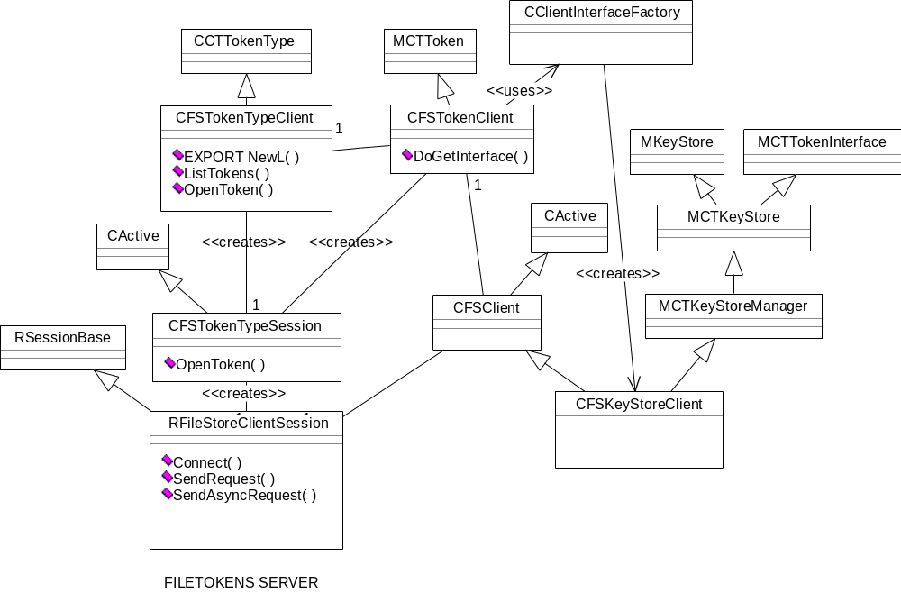

The classes implemented by the filetokens client are shown above. Most of the client code is generic and reusable for either filecertstore or filekeystore tokentypes. The single keystore specific class, CFSKeyStoreClient, provides a client side implementation of the MCTKeyStoreManager class. This class marshalls the data required to service the interface functions to descriptors, and passes it to the filetokens server, maintaining a CActive derived “state machine” for asynchronous calls and unmarshalling return data before passing back to the caller.

The filetokens server (fstokenserver.exe)
The diagram below shows the top-level classes and relationships within the filetokens server. These implement generic server and session functionality, the ctframework tokentype, tokens and token interfaces classes and a set of CObject-derived reference counting classes. Much of the code is generic and reused for each tokentype. The CObject reference counting scheme is generic for tokentype (a single instance of an object of CTokenType_ServerObject is created for each tokentype, differing only by the identifying enumeration and the MCTTokenType-derived object it reference counts). CObject reference counting for tokens and token interfaces is specific to the tokentype, and is reimplemented separately for keystore and certstore. Specific classes are created by the factory classes which can easily be extended for addition of other tokentypes.

Top level server classes and ctframework reference counting

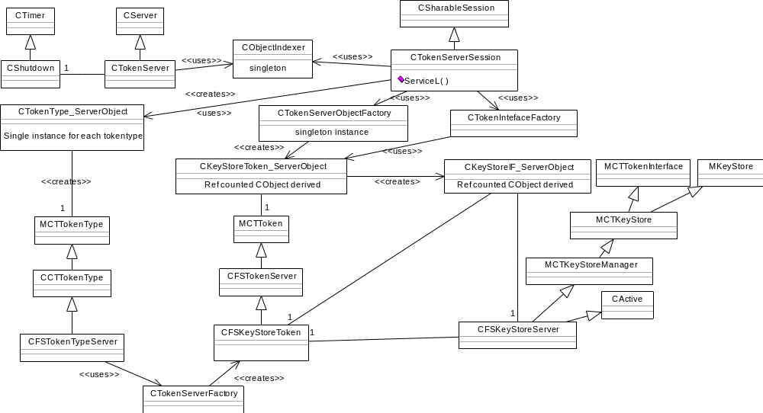

Keystore specific classes
Client requests to access keystore specific functionality (that is, calls on functions supported by MKeyStore or MCTKeyStoreManager) are forwarded by the CTokenServerSession to a “conduit” singleton instance class, CKeyStoreConduit. The conduit class interprets incoming client data for each request, provides an active object “state machine” to service requests asynchronously, and marshals return data into descriptor format to pass back across the IPC boundary to the client. Likewise, any filecertstore requests are forwarded to a separate filecertstore conduit singleton, and implementors of additional token types within the filetokens server would be required to add their own conduit.
The file keystore specific classes are shown below. All incoming client requests are received by CTokenServerSession::ServiceL() which passes them to the appropriate conduit to service them. The keystore conduit uses the object indexer to lookup the CKeyStoreIF_ServerObject object associated with the handle passed in by the client. If found, that object is used to access the keystore interface (user or manager) after checking the credentials of the caller. The user and manager interfaces are implemented by the singleton instance of the CFSKeyStoreServer class. This class uses the CFileKeyDataManager class as a single point of access to the file store, and the CKeyCreator class to create keys in a separate thread, thus providing a pseudo-asynchronous wrapper over the current key creation implementation.

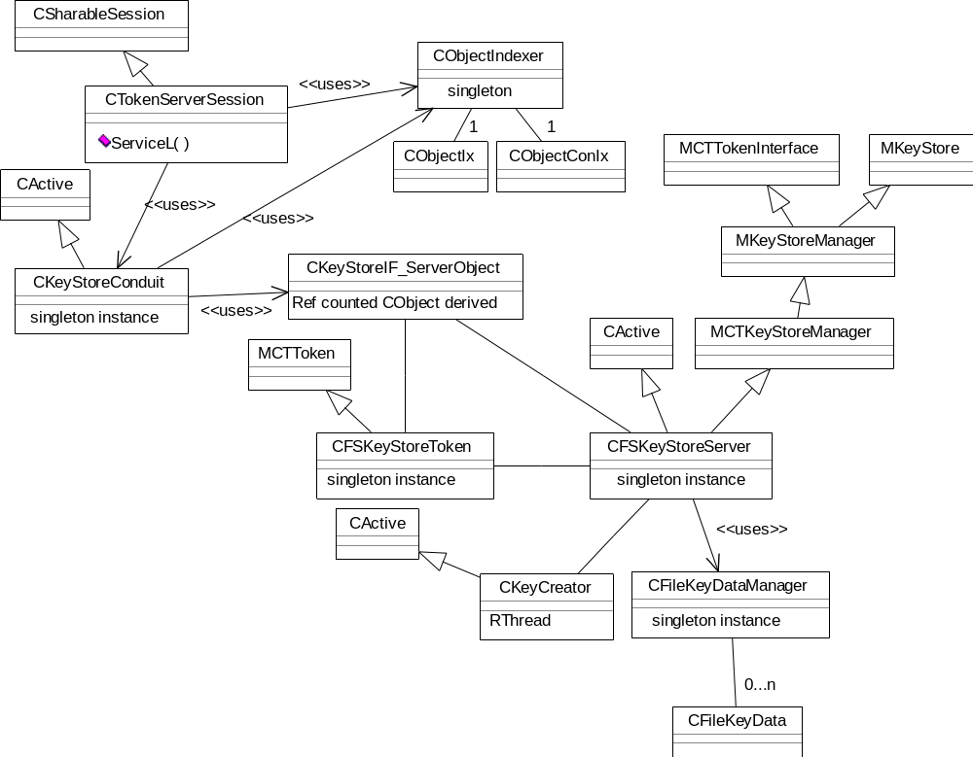

Example command sequences for standard filetokens actions
To clarify the command flow for the filetokens component, some standard activities are detailed below. These diagrams are intended as an aid to understanding the design of the filetokens components, and interaction therein. Emphasis is placed on the keystore tokentype, although the client-server startup, token opening and release and token interface acquisition substantially uses generic code.

Client-Server Startup, ListTokens and Open Token call on tokentype
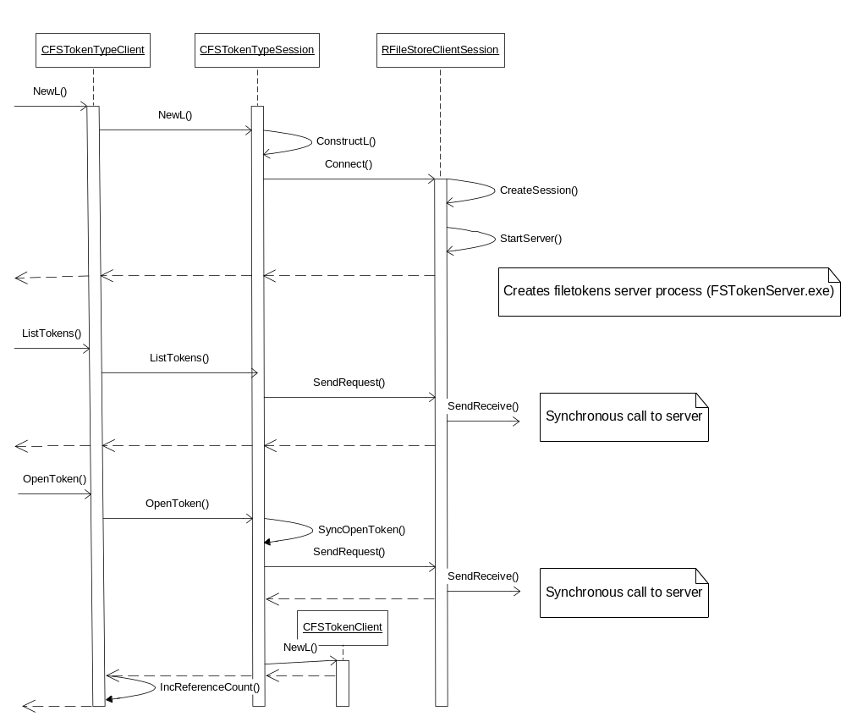

Client side token interface acquisition and release of token interface, token and tokentype
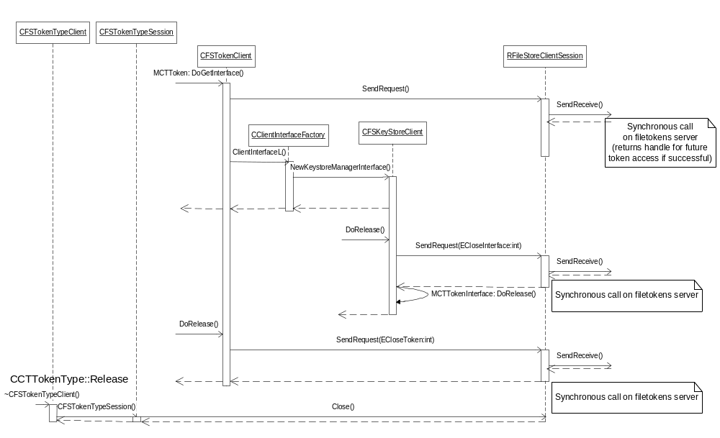

Server side opening of a token not previously opened by that server session
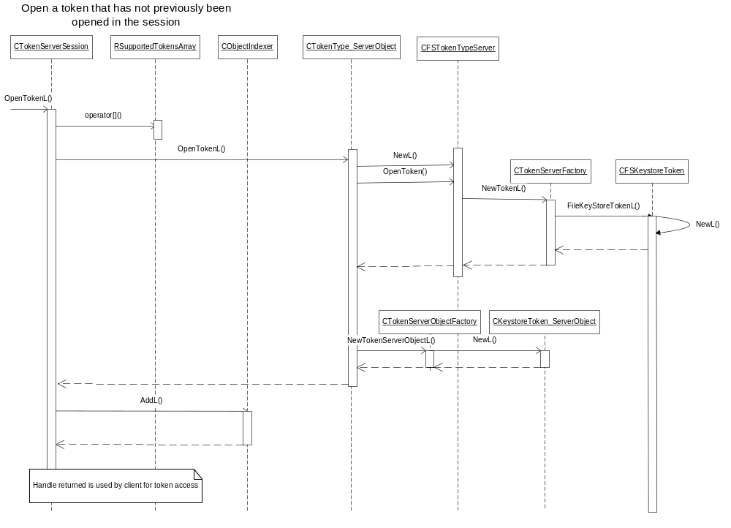

Server side opening a token previously opened by that server session
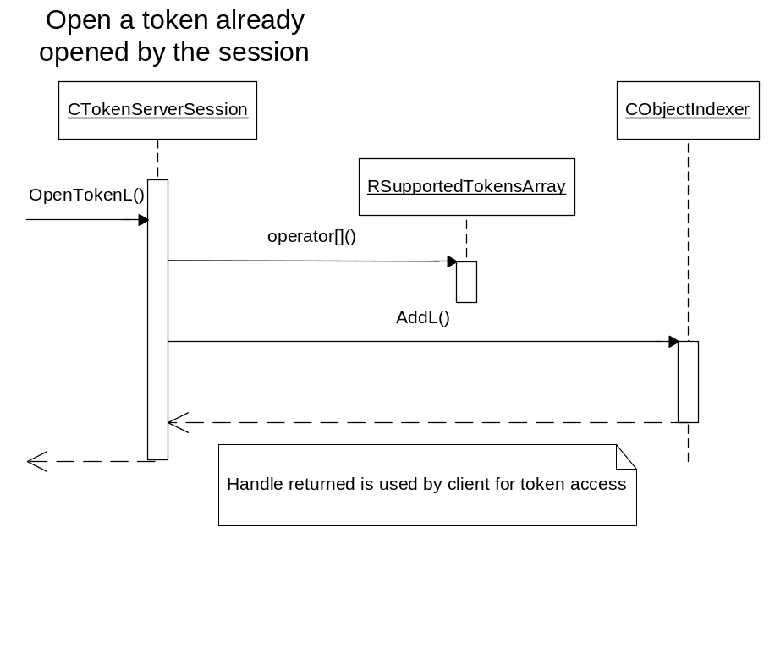

Server side opening a token interface and returning a client lookup handle to that interface
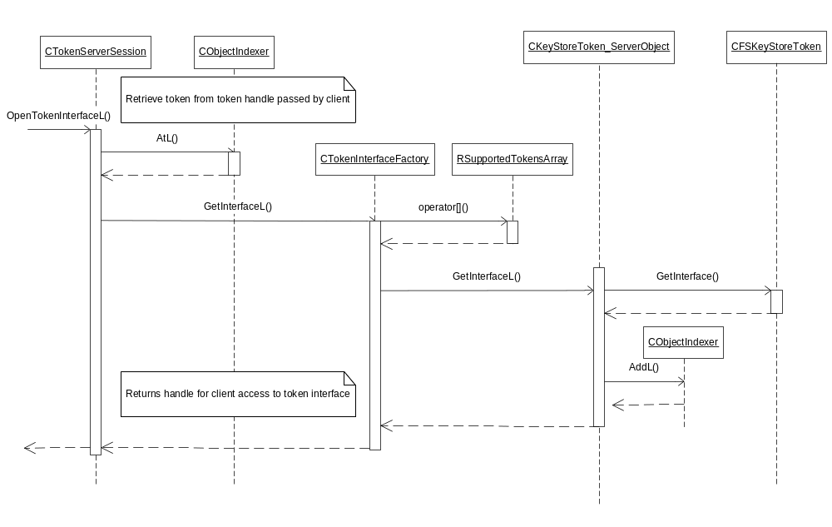

Client side key creation
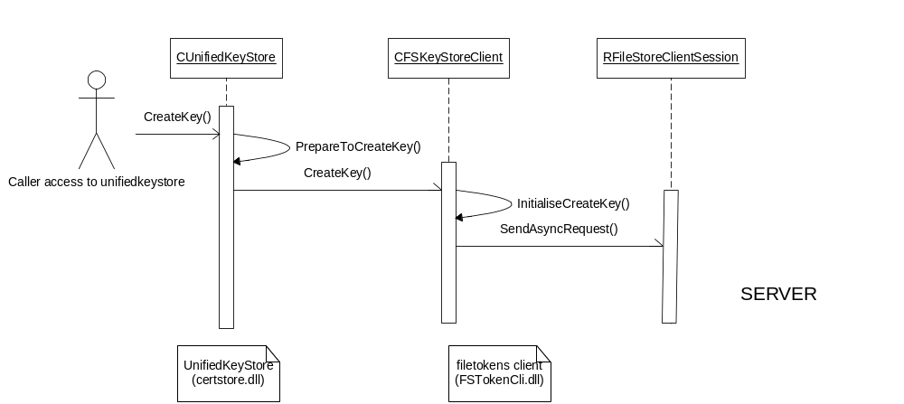

Server side key creation
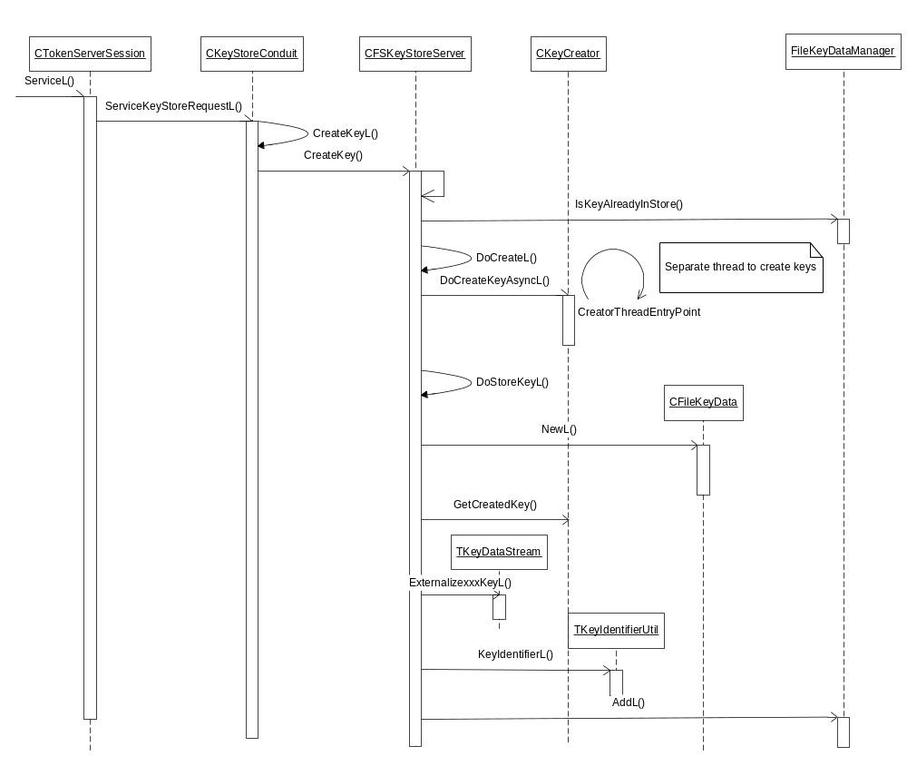

Further Information

People
Role | Person / People
Contributor(s)
Reviewer(s) | Leon Clarke, Julian Lee, Will Bamberg

References
No. | Document Reference | Version | Description
 | Requirements for security components in Jetstream |  | Jet Stream Detailed Level Requirements document: “Securing Security”
 | Top level security subsystem overview |  | Security Subsystem v7.0 Architectural Analysis: SGL.GT0128.49
 | Intranet location of in-source documentation generated for filetokens, ctframework and hash components |  | http://securitysilo.dyndns.org/doxygen/

Open Issues
The following issues need to be resolved before this document is completed;

Glossary
The following technical terms and abbreviations are used within this document.
Term | Definition

Document History
Date | Version | Status | Description
dd-mm-yyyy | 1.0 | Issued
18-09-2002 | 0.1 | Draft | First draft based on SGL.PPS001.501 Formal Document Template Rev 7.0

Document Review Date
Jetstream security subsystem A3.2 release date (19th September 2002)
- CTFramework
  - Use of CTFramework interfaces
The use of CTFramework tokentypes, tokens and token interfaces is described in a separate document generated from insource documentation and located on the intranet (http://securitysilo.dyndns.org/doxygen/).
The tokentypes currently supported by the filetokens client and server are a file-based certificate store and keystore and a certificate applications manager.
As described in the document, the file based certificate and key stores may be accessed either through CTFramework, which uses ECOM to load the filecertstore/filekeystore plugin dlls and access the filetokens client, or by statically linking against the filetokens client and calling it directly. To access a tokentype, the appropriate UID must be passed to the filetokens client. The UIDs for the tokentypes currently supported are as follows:
file based certificate store | 0x101F501A
file based key store | 0x101F7333
certificate applications manager | 0x101f7a37

